**EECE 433: Database Management Systems Course Project**

**“Healthy Diet – The Lebanese Way ☺”**

**Spring 2010-2011**

**Due Date: May 19, 2011**

**Project Objectives**

In this project, you are requested to design a system for analyzing and presenting user with healthy Lebanese (what the Lebanese eat) diet options. Towards, this goal, you will need to collect food diet nutritional information such as calorie count and vitamins, and enable its analysis to provide recommendations on healthy diet meals. The system will need to support:

1. Storing the data
2. Accessing the data
3. Displaying relevant diet information

You will need to design and develop a full system made up of at least three sub-systems with their user interfaces:

1. Display and interactively add (ie store) food items (ingredients, e.g. cucumber, apple…) along with the following for each item: unit (e.g. weight…), calories/unit, vitamins, health benefits, health hazards.
2. Display and interactively add (ie store) ingredients and cooking instructions for main dishes. The user can produce a main dish based on food items as declared previously. The system can then display each item together the information needed for cooking the dish (e.g. quantity or weight). The total calories for the main dish can then be computed, along with the contained vitamins, benefits, and hazards.
3. Display a choice of a healthy and Yummy ☺ main dish with the following related information for one person: calories, vitamins, health benefits, health hazards. The user here can select his choice to eat it.

YOU WILL NEED TO POPULATE ALL THE TABLES WITH ENOUGH INFORMATION SO THAT THERE ARE **AT LEAST TEN CHOICES OF REAL MAIN DISHES** WITH THEIR REQUIRED INFORMATION.

**Remarks:**

1. All data must have accurate measures and images.
2. A search on the internet or external source is needed to populate the tables.
3. Your application must support and display information in both Arabic and English languages, either together or the user can select a choice.
4. You must design your database using MS Sql Server, and then create a web application using ASP.net and C# to connect to the database. Other options need to be approved by the instructor.
5. You will need to divide yourselves in groups of three for this project; you must be ready to present it in the week of May 19, 2011.
6. Related screenshots and interfaces are provided below to give you some ideas for your implementations. Please note that these sample interfaces may be incomplete. They are here just to provide ideas.

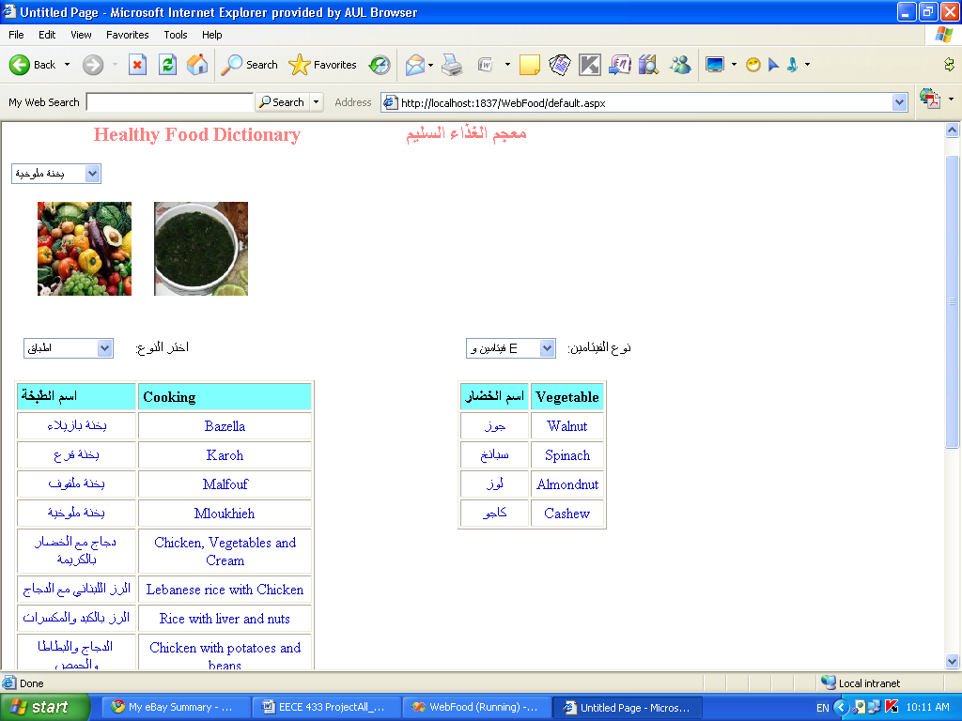

Figure 1. Sample screenshot for displaying part of individual items

In this web page, we have a display of available main dishes, we can see that the user selected Mloukhieh, we can see a picture of it, also in another gridview, we can see a list of food rich in vitamins E

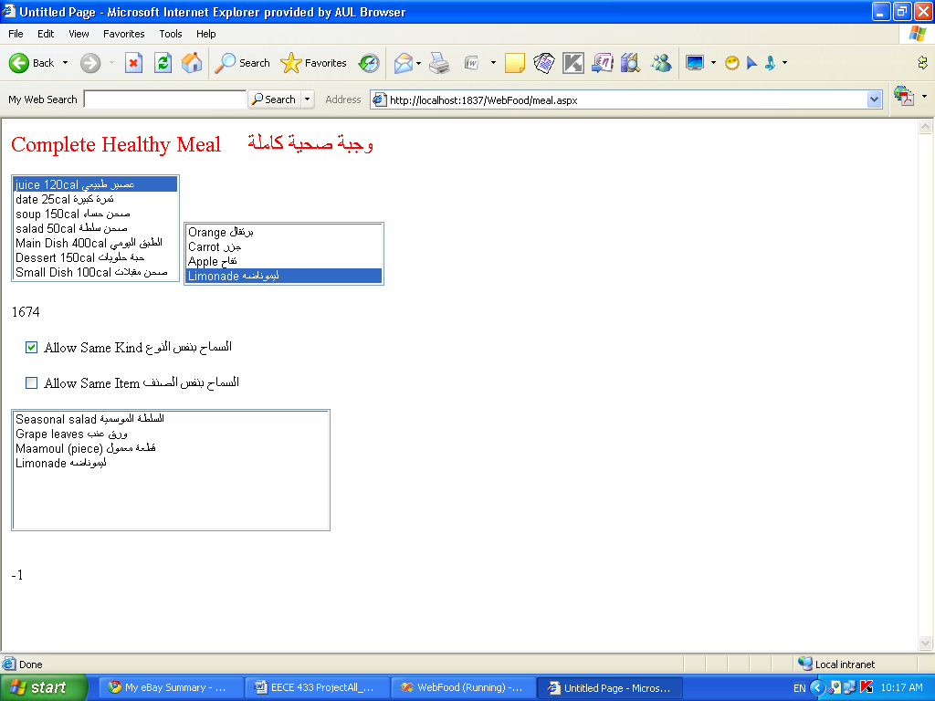

Figure 2. Sample screenshot for the diet application

In this web page, we can see that the user can select different kind of food, not only a main dish which is here just one option. Among these kinds, we have submenus to select a specific one. We have features to allow/disallow the user from different options. Finally the chosen food so far will be displayed

**Bonus**

The three sub-systems discussed above are the minimum you are required to implement. Other bonus options are numerous including:

* Selecting food for specific diseases
* Selecting food according to a client BMI (find what it is)
* Add other kind of food (dessert, juice, salads…)
* Display meaningful information about food items: rich in specific vitamins, have strong benefits in specific health areas, categorizing food by countries…
* Main plate option for more than one person.
* Pricing of food, this will include the price of the main dish and related accounting information for each client buying from the restaurant.

**Progress Report and First Presentation (10% of the project grade)**

You should present in the week of Mid April (the instructor will post the exact date later on) a first version of your project. It must consist of:

* A complete database diagram showing all the database tables and relations as printed from SQL Server Diagram.
* Some Real Data Entry in your tables that can produce at least one main dish
* At least one working interface fully integrated with SQL Server

You will show and demonstrate all these in the lab (one per group).

**Project Presentation**

You should prepare for the final presentation the following:

* A Power Point Presentation of just few pages that describe your project
* A running demo of your project showing all interfaces and features.
* A final report which should include the code and documentation that captures: Requirements, Design, Test Plan, and a user’s guide. You project grade will be based on how **well** and **easy** the program works and the clarity of the required documentation. This report has to be submitted before the project presentation that will be scheduled later on, tentatively in the week of May 19, 2011.
* The project code will be submitted to moodle, cleverly zipped.

The project presentation time for each group is fifteen minutes.